**SALVATION ORPHANAGE HOME OF FAITH**

**COMMUNITY BASED-ORGANIZATION.**

**Address: MORABI WATERLOO**

**CONTACT: +23277894917/ +23288228513**

**EMAIL:** [**salvationorphanagehome53@gmail.com**](mailto:salvationorphanagehome53@gmail.com)



* **BRIEF OVERVIEW OF THE ORGANIZATION {SALVATION ORPHANAGE HOME OF FAITH}**

The Salvation Orphanage Home of Faith is a community based organization founded in 2010, which worked as a small Orphanage caring home and a ministry to give Orphanage hope about life and God’s existence.

It developed gradually as the number of orphan children increased,it was established in 2017 as an orphanage home and school after the Ebola epidemic disease outbreak in Sierra Leone which led to the death of many Sierra Leoneans and as a result the number of orphans rapidly increased as many children lost their families.

After many terrible deaths during the Ebola outbreak, Finally Sierra Leone was declared Ebola free. Two months later the organization decided to establish a school in other to educate the orphans so that they could become self-reliance and live better lives in future.

The Organization automatically becomes a school and an orphanage home, henceforth it was name “The Salvation Orphanage Home of Faith”.

* **NAME OF ORPHANAGE HOME**: SALVATION ORPHANAGE HOME OF FAITH
* **MOTTO**: **LOVE and CARE**
* **LOCATION**: Mission Drive, Morabi-Waterloo, Western Rural District of Sierra Leone.
* **MISSION STATEMENT**: it is our right and duty as Ministry to protect and develop children and the community in which they live in the best interest to meet their unique needs for they are special in society.

Therefore children must be given special care, assistance and protection, so that they can fully assume their responsibility within the community for growth and wellbeing of all.

* **PREAMBLE**

The establishment of the school was purely to support, promote and change the life standard of orphans and the community in which they live, by supporting and strengthening grassroots initiatives for community development, self-sufficiency, health care and education etc.

* **AIMS AND OBJECTIVES**

1. It aims at providing – Food, shelter, clothing, scholarships and medical assistance (for orphans, disable, traumatized children and their families)
2. It also aim to providing school learning materials like furniture, text and exercise books, blackboards, pens, pencils, slates, school bags and toys. Etc.
3. It aims at promoting democratic citizenships in their lives as orphans.
4. It aim to help the children develop an understanding and appreciation of knowledge.
5. It also aim to help the children develop good habit.
6. It also aim at improving the life standard of children (orphans) through skills and vocational training programs in the areas of capacity, tailoring, computer literacy and micro finance projects. Like hair dressing, soap making, gara-tie dying and also aim in providing some beneficiaries (Widows) with loans for petty trading to enable support less privilege children within the community in which they live in.

* **STATUS OF THE CHILDREN**

Some of these orphans suffer greatly during and after the past deadly Ebola disease that kills a lot of family members, leaving children as orphans in year 2013.

Most of these children continue to suffer as a result to either lose both parents completely during the past epidemic disease that left unforgettable story in the mind of Sierra Leoneans.

There are also some children whose parents died on the past mudslide and flood that occurred in Sierra Leone on the 14th August 2017 leaving them orphans, and extended family survivors of this mudslide could not afford to support these suffering children due to chronic poverty.

Therefore as a community base organization“ THE SALVATION ORPHANAGE HOME OF FAITH” thought it wise to find a way for them to be assisted, through humanitarian organizations, donors, N.G.O both local and international governments and individual to elevate the suffering of these needy children for them to be useful in future.

Finally to prepare these children for a responsible life in society, in the spirit of understanding, peace, tolerance and friendship amongst people. So that they can be instrumental to the country they belong and beyond and become useful leaders of tomorrow.

* **PURPOSE FOR ESTABLISHING THE SALVATION ORPHANAGE PRE-PRIMARY SCHOOL**

Salvation Orphanage Pre-Primary School is a community based parochial school as stated before. The school came in to existence in the year 2010. The circumstances that generated the inception of the school are rooted in the philosophy nature and university of knowledge.

The genesis of salvation orphanage pre-primary school was generated with a need for both pre-primary &secondary school in the community and could neither not send the orphans to any school as there was no school in that part of the community.

THE SALVATION ORPHANAGE HOME OF FAITH executive came together with the community stakeholders and proposed the establishment of the pre-primary school institution. At the meeting, the executives spelt out advantages of giving their children formal education, it was also spelt out that education can serve as an investment to the parents and also as an instrument for economic growth, social and ethnic polarization.

It was also envisaged that education will promote equitable development and build a culture of dialogue rather than violence.

The educational engineers and the community leaders agreed in principles and practice – salvation orphanage pre-primary & secondary school will be used as an instrument for the production of new student, expansion and transmission of the catholic faith and doctrines, norms and values of the community.

* **VISION STATEMENT**

By the year 2050 all category of children irrespective of religion, cultural backgrounds, colors and sex school have achieved quality education.

They will serve God and humanity through the provision of sound and affordable quality education so as to ensure pupils rights and self-esteem. To exhibit higher academic excellence by excelling in both internal and external examinations.

* **ORPHANAGE HOME AND SCHOOL SITE VIEW**

The Salvation Orphanage School is located in Mission Drive off Joe Town Road Morabi, Waterloo in a very flat land inhabited by different set of people, poor from different part of the country majority are peasants and technical workers.

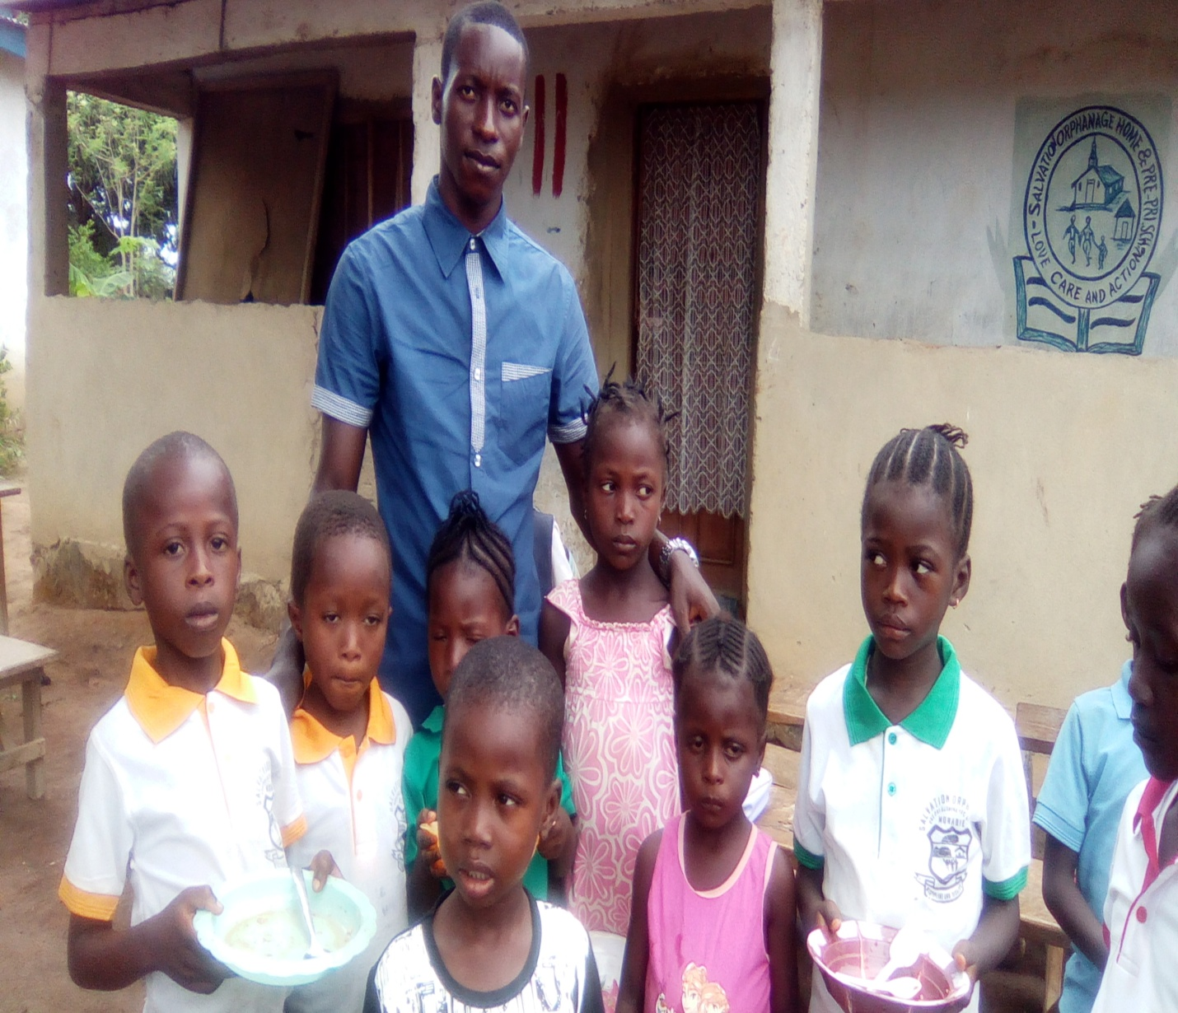

Having Lunch and fun as a big family in Christ Jesus.

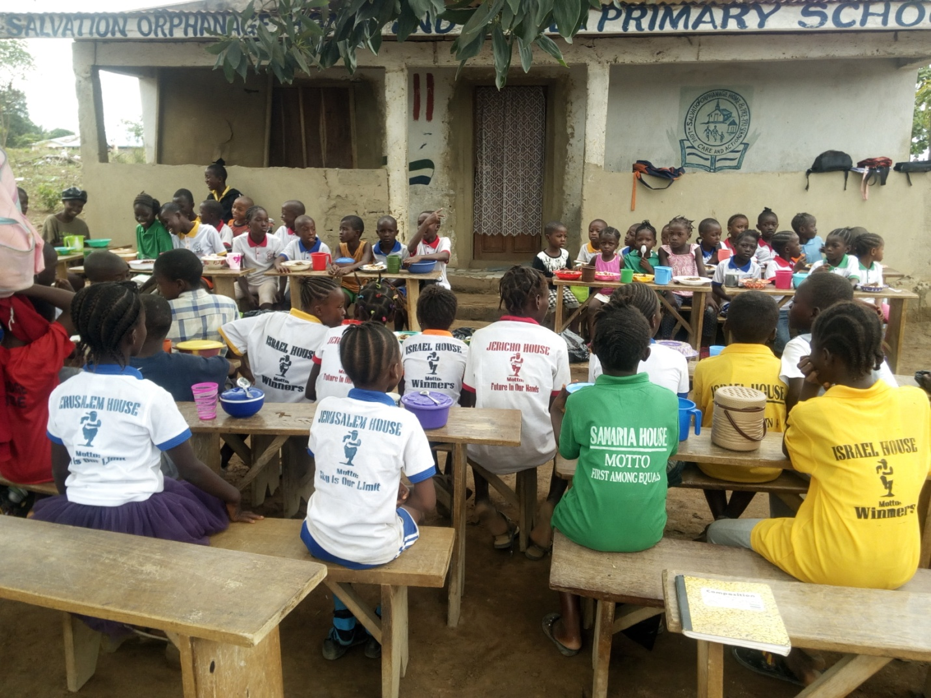

**Orphans need Love, Fun, Care and other activities to restore their lost happiness.**

**A moment with an orphan will be very amazing as they are very brave and talented in telling stories and doing innovations and artistic work.**

**Brilliant and passionate kids about achieving education and make the world a better place.**

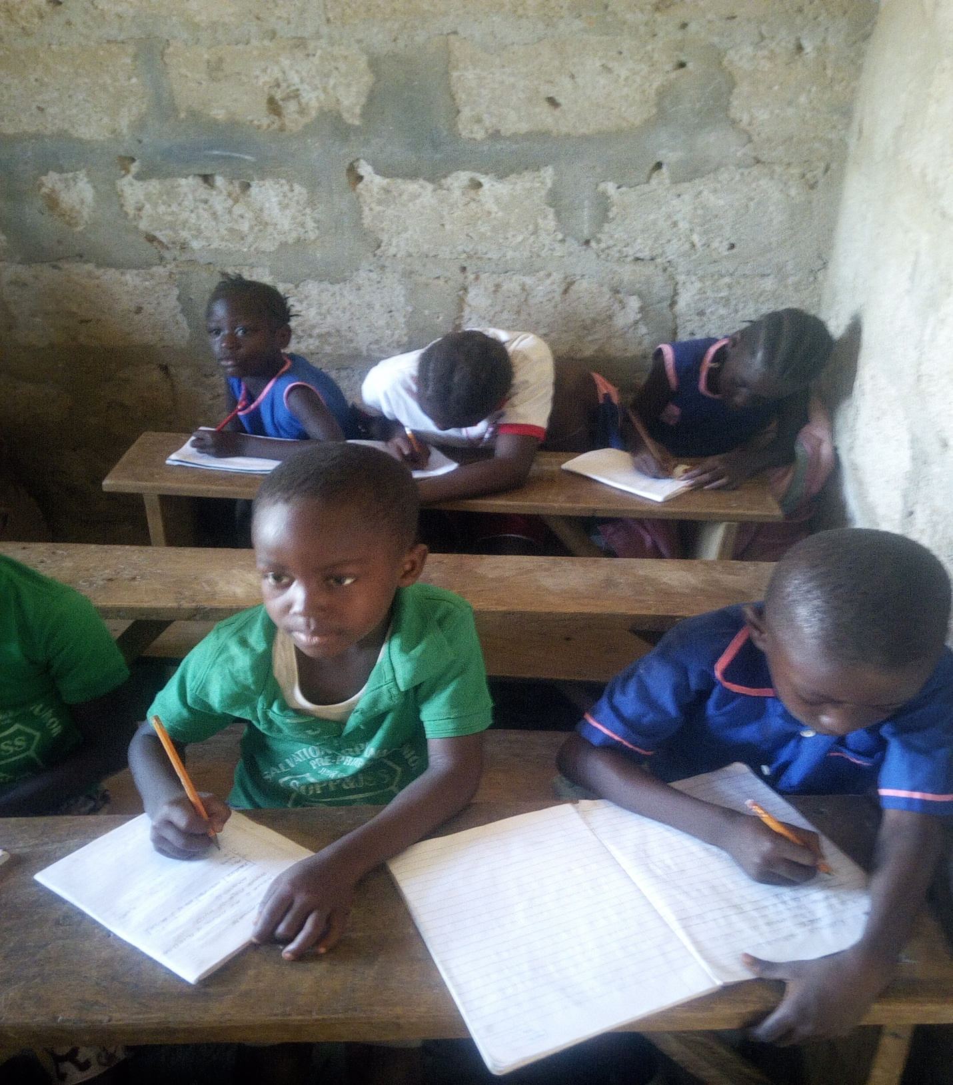

**These passionate poor orphans deserves education and better future, Learning materials and conducive learning environment will gives more hope and determination. ‘HELP EDUCATE AN ORPHAN CHILD TO RESTORE THEIR HOPE’.**

* **OBJECTIVES FOR ESTABLISHING THE ORPHANAGE SCHOOL**

The general objectives for establishing the Salvation Pre-Primary School is to enable the orphans to:

* Be physically fit and healthy/healthy according to his/her ability to become self-reliance
* Identify problems and find solution to them to empower them
* Improve communication skills including listening, reading and writing to make a different in the society.
* Gain self-esteem and positive attitude to create a friendly society
* Develop the whole child physically, mentally, morally, socially and emotionally.
* Help the orphans understand themselves and enjoy their civil right to education
* Think critically and develop things on their own with self-innovation
* Distinguishing between right and wrong.
* Love God, his/her families and members of the community.

OPERATIONAL AREAS

The Salvation Orphanage Home of Faith as a Community –Based Organization aim at helping orphans it operational areas are as follows:

* Orphanage Home care
* Orphanage school
* Technical institutions for orphans

**Source of Funding**

The Salvation Orphanage Home of Faith is a Community-Based Organization that get funding through the following ways:

* Monthly subscription from board of executives
* Donations
* Fund raising activities
* Mission support

**NAMES OF EXECUTIVE MEMBERS IN THE SALVATION ORPHANAGE HOME OF FAITH ORGANIZATION**

|  |  |  |  |  |
| --- | --- | --- | --- | --- |
| **Names** | | **Address** | **Contacts** | **Positions** |
| 1. | Reverend Joseph Abu Conteh | Off Joe Town, Morabi Waterloo | +23288228513 | Director |
| 2. | Mr. Alfred Mans Turay | 10 Old Road, Waterloo | +23277894917 | Secretary / Coordinator |
| 3. | Mr. Samuel Okoli Dumbuya | 2 Abb Line York Road Waterloo | +23288745428 | Legal Adviser |
| 4. | Mr. Hassan A Conteh | Off Joe Town, Morabi Waterloo | +23288532125 | Chief Officer |
| 5. | Miss Mariatu Turay | Kamajor Bridge Waterloo | +23288617252 | Treasurer |
| 6. | Miss Pamela O.C Williams | Godrich street ,Freetown |  | International Coordinator |
| 7. | Miss Fatmata Aliciatu Conteh | 10 Old Road, Waterloo | +23299028437 | Financial Secretary |
| 8. | Miss Elizabeth N Bangura | 11 Morabi Road, Waterloo | +23277559569 | Matron |

**CONSTITUTION OF THE SALVATION ORPHANAGE HOME OF FAITH ORGANIZATION.**

The executive board of the Salvation Orphanage Home of Faith enacted this constitution to govern Salvation Orphanage Home of Faith as a Community Based Organization.

* **CHAPTER 1.1 DUTIES OF THE BOARD OF EXECUTIVES**

Board of Executives are responsible for ensuring effective and fiscally sound programs and operations. They do this by providing leadership, advice and direction to the staff and volunteers of the organization

1. Prepare for each Board of Directors meeting by reading material distributed prior to the meeting.2. Attend all regular and special Board meetings and participate in proceedings.3. Serve on at least one committee and actively participate in meetings of the committee.4. Maintain knowledge of current programs and staff of the organization.5. Make a personal financial contribution to the organization.6. Solicit the financial support of others, including employers and friends.7. Share resources and talents with the organization, including expertise, contacts for financial supports, and contacts for in-kind contributions.8. Serve as an advocate of the organization.9. Be accessible, at least by phone, to staff and other Board Directors as needed.10. Contribute at least 300 hours per month to working for the organization.11. Fulfill commitments within the agreed-upon deadlines.12. Be loyal to the organization.13. Maintain the confidentiality of any information given to Board Directors.

* **CHAPTER 2.1 DUTIES AND RESPONSIBILITIES OF THE DIRECTOR**

The Director help to provide leadership and direction to the membership and the governing board of the organization, by ensuring that all executive members understand and exercise their responsibilities with regard to the management of the organization's programs and finances.

1. Act as principal executive officer of the organization assisted by the project coordinator

2. Prepare agenda for membership meetings.

3. Prepare agenda for Board meetings.

4. Preside over all regular and special membership meetings.

5. Preside over all regular and special Board meetings.

6. Sign, with other appropriate officers, corporate and legal documents assisted by the secretary.

7. Maintain current knowledge of programs and activities.

8. Act as principal spokesperson for the organization

9. Prepare agenda for Executive Committee meetings.

10. Preside over Executive Committee meetings.

11. Supervise standing committee chairpersons.

12. Facilitate communication between Board and staff.

13. Ensure Board follow-through on all assigned tasks.

14. Assist in orientation of the Directors.

15. Supervise the Executive Board.

* **CHAPTER 2.2 DUTIES AND RESPONSIBILITIES OF THE PROJECT CORDINATOR**

The Project Coordinator ensure continuity in the leadership of the organization by supporting and assisting the Director1. Preside over membership meetings in the absence of the Director.2. Preside over Board meetings in the absence of the Director3. Support the current Director4. Become oriented to all duties and responsibilities of the Director5. Attend and participate in Executive Committee meetings.6. Chair a standing committee and fulfill committee chairperson position description.7. Assist in orientation of new Directors and members.8. Perform other duties as assigned by the Director

**QUALIFICATIONS OF A PROJECT CORDINATOR**

1. Excellent communications skills in oral and written self-expression.2. Proven leadership ability.3. Knowledge of and skills in planning.4. Ability to facilitate meetings.5. Knowledge of and commitment to the purpose and programs of the organization.6. Ability to work in a team and, with great interpersonal skills.

* **CHAPTER 2.3 DUTIES AND RESPONSIBILITIES OF THE TREASURER**

The Treasurer provide financial management and fiscal controls for the organization.

1. Monitor receipt of all securities and monies due to and held by the organization.

2. Ensure that all funds are properly deposited and disbursed in a timely manner.

3. Render monthly, quarterly and annual financial reports of the organization to the Board of Executive.

4. Ensure that all Federal, State and local financial reports are filed on a timely basis.

5. Oversee the preparation of the annual budget and monitor its implementation.

6. Ensure that the organization maintains its tax-exempt status.

7. Oversee the design and implementation of an appropriate bookkeeping and accounting system.

8. Contract with an independent CPA to conduct an annual audit.

9. Sign fiscal forms and instruments as necessary.

10. Attend and participate in Executive Committee meetings.

11. Attend and participate in fundraising meetings as necessary.

**QUALIFICATIONS**

1. Knowledge of fund accounting systems and internal controls.

2. Ability to analyze and dearly present financial statements.

3. Knowledge of financial reporting requirements for pertinent regulatory agencies.

4. Ability to work in a team and, where appropriate, to delegate responsibility.

5. Ability to develop methods for maintaining positive cash flow.

6. Knowledge of and commitment to the purpose and programs of the organization.

7. Knowledge of and skills in financial issues

* **CHAPTER 2.4 DUTIES AND RESPONSIBILITES OF THE SECRETARY**

The Secretary oversee the record keeping and correspondence of the membership and the governing; board of the organization, ensuring compliance with relevant provisions of the bylaws; compliance with the State's not-for-profit corporate laws; and IRS regulations.

1. Record and sign the minutes of the meetings of the membership.

2. Record and sign the minutes of the meetings of the Board.

3. Send notices in accordance with the provisions of the bylaws, or as required by the law.

4. Ensure that organizational records are protected for long-term safekeeping.

5. Maintain directory of members and the Board, including names, addresses, phone numbers and current position within the organization.

6. Sign appropriate organizational documents as needed.

7. Monitor parliamentary procedure, as needed.

8. Maintain organization Record Book.

9. Sign official corporate correspondence.

10. Update bylaws, as needed, when relevant Board resolutions are adopted.

11. Attend and participate in Executive Committee meetings.

**QUALIFICATIONS**

1. Knowledge of laws pertaining to not-for-profit organizations.

2. Knowledge of parliamentary procedure.

3. Good listening skills.

4. Ability to summarize information into concise statements.

5. Knowledge of and commitment to the purpose and programs of the organization.

6. Ability to work in a team and, where appropriate.

* **CHAPTER 2.5 DUTIES AND RESPONSIBILITIES OF FINANCIAL SECRETARY**

The Financial Secretary receive record and deposit all funds taken into the organization treasury, and forward information to the Treasurer for use in support of the organization activities.

The responsibilities and duties of the Financial Secretary includes:

1 .Work according to the policies and procedures established by the Board of executive

2. Receive record and receipt funds from all sources and report them to the Treasurer or auditor general.

3. Receive donations and monthly subscriptions collected.

4. Ensure funds are deposited in a bank as soon as possible after they are received. Deposits should be made within three days of receipt.

5. Establish a procedure to collect and record funds received other than through regular monthly subscriptions or fund raising, including funds received by mail or electronically.

6. Produce individual charitable gift report summaries of all donations received during a calendar year and mail within two weeks of the end of that year.

7. Report regularly to the Executive Board regarding total funds pledged and actual amount received for the year.

8. Inform and encourage regular, systematic giving donors through providing information regarding electronic giving.

9. Maintain confidentially of all financial information pertaining to receiving, recording and depositing of funds.

**QUALIFICATIONS**

* Basic understanding of accounting procedures.

• Trustworthiness; honesty.

• Confidentiality.

• Enjoys working with numbers.

• Attention to detail; accuracy.

• Commitment to the organization and its mission.

• Ability to work with the financial team.

• Ability to attract and support volunteers.

• A positive image of the task.

* **CHAPTER 2.6 DUTIES AND RESPONSIBILITIES OF THE MATRON**

DUTIES AND RESPONSIBILITIES OF THE MATRON

The position of the Orphanage Home Matron is one of significant role and responsibility in the organization. The Matron has a special role in helping the Orphans to create a happy and well-disciplined atmosphere throughout the Home. The success of a Matron’s appointment depends on the establishment of a harmonious relationship with the children and the organization based on mutual trust.

Working under the direction of the organization, the House Matron is required to play a key role in the pastoral care of all the orphans in the orphanage home on a day-to-day basis, with particular responsibility for the physical, social and emotional well-being and presentation of the orphans in the Orphanage home.

Ultimately, the objective of the Home Matron is to play a significant role in establishing a ‘home away from home’ environment in which the orphans are at ease and are happy.

**DUTIES AND RESPONSIBILITIES OF THE MATRON**

1. The Matron is a member of the residential House team, alongside an assistant House Mistress.
2. The Matron is responsible for the pastoral care, health and welfare, and health education of the orphans in the Home.
3. There are other non-residential members of the House team which include House Tutor to collaborate with the matron
4. The Matron reports directly to the Home mistress on all matters relating to the welfare of the orphans and the fabric of the Home.
5. The Matron ensures that the right care is given to the orphans and monitors their well-being at all times. This is done by facilitating and contributing to the various routines of the House, which seek to promote the confidence of the orphans within a happy atmosphere. These routines encourage high standards of dress, cleanliness and respectful relationships with the orphans

* CHAPTER 3. 1 CIVIL RIGHT PROTECTION.

The Salvation Orphanage Home of Faith Organization ensures full protection of the fundamentals human rights and liberties of the orphans, which is in accordance with the child protection act of the republic of Sierra Leone.

1. Right to life
2. Right to liberty
3. Right to security
4. Freedom of conscience and respect for private and family life when they attained the age of 18-21

* CHAPTER 3.2 ORPHAN ADOPTION

The organization carries it necessary procedures in other for a child to be adopted as an orphan to the orphanage home. The necessary procedures are:

1. Consult families/ neighbours/community stakeholders
2. Relatives of an orphan and the organization must sign documents indicating the presence of an orphan in the orphanage home
3. The child must be an orphan

* CHAPTER 3. 3 SOLIDARITY

The organization must be a non-partial humanitarian organization whose sole aim is to help orphans.

1. No tribal discrimination
2. No other form of discrimination like orphans with disabilities like blindness, deaf, dumb, cripple.

* CHAPTER 3.4 MORALITY

The organization take care of orphans to enable them become self-reliance and thus at age 18-21 they could no longer be considered orphan child [OC1] but adult orphans [AO2]. Thus they are allowed to live and setup their home for future as family or private life that will be monitored by the organization.

* CHAPTER 3.5 INDEPENDENT

The organization provides home for orphan children age 3 – 18 years to live in the orphanage home and acquired formal education and other lucrative skills.

1. Orphans at the age of 16 and above who may want to live outside the orphanage home should be allowed to do so but under proper supervision and if found culprit of any evil practices during the process he/she should be reprimanded twice and if he/she persist then the organization will automatically expel him/her.

* CHAPTER 3.6 UNION

Orphans of an age ranging 5 years and above who will be fortunate to get help from any of our partners or sponsors in future will be allowed to enjoy that privilege base on the following procedures:

1. If to take an orphan out of the country, the organization should inform the orphan’s families /neighbours /stakeholder for approval.
2. The organization should also follow all legal travelling regulations governing the republic of Sierra Leone.

* CHAPTER 4.1 COMMITMENT

Executive members of the organization should work in the best interest of the orphans in other to ensure the protection of their civil rights and liberties

1. Any executive member who is found guilty of any evil practices against the orphans should be severely punished by the board of executives.

* CHAPTER 4.2 EMPATHY

Any gross misconduct by an orphan must be handled with love and care

1. Issues relating evil practices or misbehaviour of orphans should be addressed by the founder.

* CHAPTER 5.1 PROFESSIONALISM

Issues relating mismanagement or misappropriation of funds or material will be discuss by

I. The executives and appropriate decision will be taken by the executive director and the founder.

CHAPTER 6.1 SUSTAINABILITY

The organization carryout several operations in other to support the orphans which are done by the board of executives.

These operations are done in other to train the orphans, such operations or activities which the organization carry out are clearly spelt below:

1. Establishing technical vocational institute and advanced learning system (technology).
2. Establishment of vocational training like baking breads, cakes, etc. Which the organization could use to feed the orphans and impacting skills on them.

**ANNUAL WORK PLAN FOR 201 9- 2020**

**PROJECT: REHABILITATION OF ORPHANAGE HOME AND SCHOOL.**

|  |  |
| --- | --- |
| **Objectives:**  By the end 2020 we will already finished rehabilitating the Orphanage home and School  and also repair the benches and desks. | Date |
| 2019­­-2020 |
| **Major Activities:**  - Conduct a general board meeting | 25tH /06/2019 |
| -Conduct a fund raising programme within and out of the organization | 5tH/O7/2019 |
| -Develop a strategic plan  -Implementing the strategic plan | 15th /07/2019 |
| **Expected Output:**  -5 Planning meeting will be held ………………………………………………………………  -1 Strategic plan will be developed {arrangement on construction of blocks}……  -1 Strategic plan will be implemented {construction of blocks}……  -8 strategic plan will be implemented { Block laying, roofing, plastering, tiling, furnishing , painting ,electrifying ,making benches and desks} | 20th /07/19- 25th |
| 28th /07/19 |
| 30th /07/19 |
| 1st /08/19 |
| 5th/11/19 |
| **Expected Outcomes:**  -Self –advocate leaders will use their leadership skills and knowledge to effectively operate the Orphanage Home and School  -Launching of the new rehabilitated orphanage home and school  The board of executives will set up the executive structure to operate |  |
| 10th /12/2020 |
| 12th /12/2020 |
| **Data Evaluation and Management:**  -The organization will review sign-in sheets and meeting agendas to examine the performance  -Set up a focus group from the executive to held meeting trying to evaluate the process and the use of the newly impacted individual skills.  - An executive group will be set as a self –advocate group to evaluate the increase knowledge in planning | 15th/12/2020 |
| 15th/12/2020 |
| 15th/12/2020 |

**SALVATION ORPHANAGE HOME OF FAITH**

**FOR COUNTRY & HUMANITY**

**THE CHILDERN OUR FUTURE &OUR HOPE**



WE LOVE YOU ALL KIDS

Orphans kids from Sierra Leone

